Name – Ayush Mondal

Dept – CSE , 2nd year , 4th sem

Sec – A

Assignment no – 5 (Subject os)

1. SJF program

#include <stdio.h>

void main()

{

int bt[20], p[20], wt[20], tat[20], i, j, n, total = 0, pos, temp;

float avg_wt, avg_tat;

printf("Enter number of process:");

scanf("%d", &n);

printf("\nEnter Burst Time:\n");

for (i = 0; i < n; i++)

{

printf("p%d:", i + 1);

scanf("%d", &bt[i]);

p[i] = i + 1;

}

// sorting of burst times

for (i = 0; i < n; i++)

{

pos = i;

for (j = i + 1; j < n; j++)

{

if (bt[j] < bt[pos])

pos = j;

}

temp = bt[i];

bt[i] = bt[pos];

bt[pos] = temp;

temp = p[i];

p[i] = p[pos];

p[pos] = temp;

}

wt[0] = 0;

for (i = 1; i < n; i++)

{

wt[i] = 0;

for (j = 0; j < i; j++)

wt[i] += bt[j];

total += wt[i];

}

avg_wt = (float)total / n;

total = 0;

printf("\nProcess\t Burst Time \tWaiting Time\tTurnaround Time");

for (i = 0; i < n; i++)

{

tat[i] = bt[i] + wt[i];

total += tat[i];

printf("\np%d\t\t %d\t\t %d\t\t\t%d", p[i], bt[i], wt[i], tat[i]);

}

avg_tat = (float)total / n;

printf("\n\nAverage Waiting Time=%f", avg_wt);

}

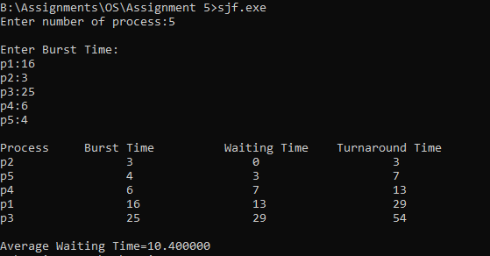

1. FCFS program

#include <stdio.h>

typedef struct Pro{

int aT , bT , cT , tAt , wT ;

}Prog;

int main(){

int numProg;

printf("Enter the number of Program you want to run : ");

scanf("%d" , &numProg);

Prog program[numProg];

int timeLine = 0;

float avgWt = 0;

for(int i = 0 ; i<numProg ; i++){

Prog p1;

int at , bt;

printf("Enter the Arrival time of the program :");

scanf("%d" , &at);

printf("Enter the Brust time of the program :");

scanf("%d" , &bt);

p1.aT = at;

p1.bT = bt;

program[i] = p1 ;

}

for(int j = 0 ; j<numProg-1; j++){

for(int i = 0 ; i<numProg-j-1 ; i++){

Prog p1 = program[i];

Prog p2 = program[i+1];

int at = p1.aT , at2 = p2.aT;

if(at > at2){

program[i] = program[i+1];

program[i+1] = p1;

}

}

}

for(int i = 0 ; i<numProg ; i++){

if(i==0){

timeLine = timeLine + program[i].aT + program[i].bT;

program[i].cT = timeLine;

program[i].tAt = program[i].cT - program[i].aT;

program[i].wT = program[i].tAt - program[i].bT;

}

else{

timeLine = timeLine + program[i].bT;

program[i].cT = timeLine;

program[i].tAt = program[i].cT - program[i].aT;

program[i].wT = program[i].tAt - program[i].bT;

}

}

for(int i = 0 ; i<numProg ;i++){

printf("program no : %d \n" , i);

printf("Arrival Time : %d \n" , program[i].aT);

printf("Brust Time : %d \n" , program[i].bT);

printf("Completion Time : %d \n", program[i].cT);

printf("Turn Arround Time : %d \n" , program[i].tAt);

printf("Waiting Time : %d \n" , program[i].wT);

printf("\n\n\n");

}

for(int i = 0 ; i<numProg ; i++){

avgWt = (float) (avgWt + program[i].wT);

}

avgWt = avgWt / numProg;

printf("Avarage Waiting Time : %.2f " , avgWt);

}

